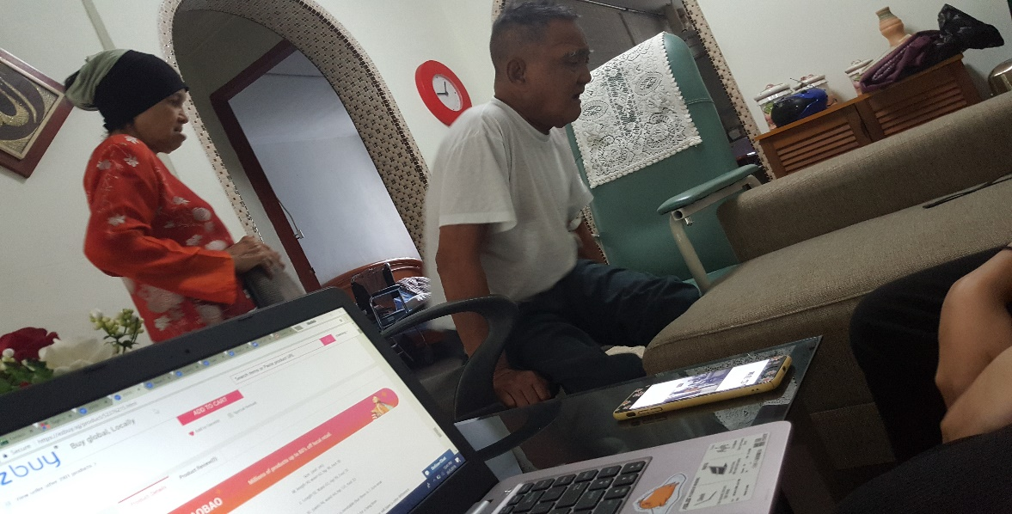

“We come to love not by finding a perfect person, but by learning to see an imperfect person perfectly.” **-Sam Keen**

**This photo was taken when Mr Mahfod needed to go to the washroom. as he could not move freely, his wife uses an office chair to push him around the house. Despite Mr Mahfod’s conditions, Mrs Sapiah, willingly took care of him without complaining. It was touching to witness and to feel the love she had for him.**

A life of a man, who tried his best to stay positive when faced with obstacles in his life. Mahsuni Bin Mahfod, 76 this year, currently retired from an F&B industry at HomeTeam Academy company. He retired as he felt tired and starting to reach the retirement age. Mr Mahfod is a very cheerful and open-minded person. He is the eldest in his family together with his two younger sisters. Currently, he is living together with his wife and daughter in a 3-room flat. He has 5 children of 2 daughters and 3 sons whom he is still in contact with all of them. His daily routine, apart from the usual eating, sleeping is also taking medicine frequently. He reads the newspaper to prevent him from falling asleep.

Furthermore, he even takes a stroll around the neighbourhood and sits under the void deck with his friends. He does not have any specific hobbies however, he does like to browse the newspaper and keep up to date with the Malay news on television. His daily needs include eating, sleeping and regularly drinking plain water. He also needs to take his medicine regularly and have to get injections on every Tuesday, Thursday, and Saturday and he also needs to watch his eating habits.

Everything started 10 years ago when he used to eat non-home cooked food often and also was a heavy smoker. One day, he started to feel pain in his kidney/stomach area for quite some time. He decided to visit a doctor. The results were that he had a bad kidney which was caused by eating too much unhealthy food and smoking. When he heard about the sad news, he was not upset nor depressed about it as he felt that it was God's will.

However, as time goes by, he had a sudden mild stroke which had happened at his house 10 years ago. This caused concerns to his family as he was hospitalized for around few days and could not move his body. Hence, he had to go through therapy to help strengthen his legs. During his stay at the hospital, he was able to recover but the after effect of the stroke caused him to lose strength in his leg and eventually lead to him having difficulties to walk and have to use a wheelchair.

This accident had made him struggle including simple things such as the struggles to go to the washroom, obstructing him from going to places freely, struggle getting out of the wheelchair. Apart from challenges, he must visit the hospital most of the time, having a strict diet, cut down on smoking, have lots of injection with marks still visible.

Fortunately, He does not encounter any discrimination as he loves and care from the people around him. When asked about his dreams and aspirations, he said he had already achieved what he hope to do such as building a family, witnessing his children grow up healthy and happy. If there a chance, Mr Mahfod would want to spend more time with my children as he spends most of the time working while his children were growing up. He did not have time to spend time with them and getting to know more about their school life and progress. His wife had a hard time taking care of the kids single handed while he was away, and he felt that if he did not have spent too much time working and had prioritised family first, at least he get to show his love and care towards them.

Lastly, He has some words of advice that he would like to convey to everyone. Firstly, he advices everyone to try not to eat unhealthy food too often and it is best to eat homemade food as it is healthier and cheaper compare to outside food. Also, he would like people to cut down their sugar and salt intake and it is bad for health. Lastly, do not smoke too much as it affects the kidney. He would not want anyone to suffer like what he did.

* A short proposal of how each person’s daily needs and struggles, dreams and aspirations can be met through existing initiatives (not more than 400 words each).

If you have **diabetes**, your blood glucose, or blood sugar, levels are too high. Over time, this **can** damage your **kidneys**. ... If they are damaged, waste and fluids build up in your blood instead of leaving your body. **Kidney damage** from **diabetes** is called **diabetic nephropathy**.

Need and proprotoes of individuals and families? Problem n challenge

Assest and resoucse they have, strength.

What motive you?

What is your long run personal goal

* A short description of how you have shown your appreciation to each person in a meaningful way for the time taken for the interview (of course this needs to be done before you submit your assignment).

While having a conversation with Mr Mahfod, I understand that he has been controlling his diet to eat more health to not worst his conditions. He does not seem to in need of any entities,